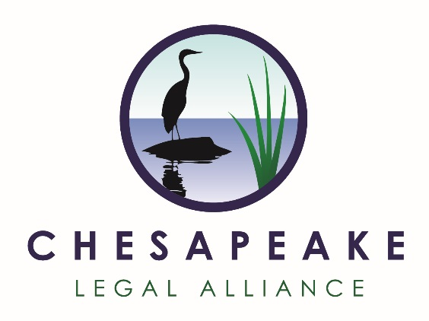

Resolution Regarding Board Structure
Be it resolved that, in accordance with the Bylaws, the Board of Directors be divided into three classes as follows:
Class 1 – Term Expires December 31, 2021
Robert Kremens
Stephen Kurzman
Vince Leggett
Frank Leone
Lois Schiffer
Joyce Schlesinger
Skip Shipman
Marty Siegel

Class 2 – Term Expires December 31, 2022
Richard Hinds
Rick Hoffman
Nancy Merrill
Mike Ross
Russell Stevenson
David B. Weinberg
Kenneth Weinstein

Class 3 – Term Expires December 31, 2023
Thomas Barba
Patrick Coyne
Charles Garlow
Ridgway Hall
Deborah Jennings
Hal Marcus
David Menotti
Robert Sussman

